Dear Editors of *Journal of Animal Ecology*,

We are pleased to submit the manuscript entitled “**Carcass size, not source or taxon, dictates breeding performance and carcass use in burying beetle**” for consideration as a *Research Article* paper in *Journal of Animal Ecology*.

The breeding biology of burying beetles is a fascinating area of research and has been frequently used to test ecological hypotheses. However, most studies have used laboratory-reared carcasses of limited sizes, raising questions about whether these results are representative of the patterns in the wild. Our work addresses this question by using a broad range of carcass sizes from both lab and wild sources, capturing for the first time optimal breeding outcomes on medium-sized carcasses. Moreover, our findings demonstrate that breeding outcomes, carcass use, and larval growth do not differ between carcass sources or among carcass taxa (mammal, bird, and reptile), despite variations in the nutritional composition of carcass tissue. Finally, we identified a larval quality-quantity trade-off across the range of carcasses studied, and the larval life-history traits can shift depending on carcass size. Importantly, our study validates decades of research using lab carcasses to study the reproductive ecology of burying beetles.

We believe our novel findings will be of great interest to the scientific community and the readers of *Journal of Animal Ecology*. We declare that this manuscript is original, has not been published before, and is not under consideration for publication elsewhere. We have no conflict of interest to disclose.

Thank you very much for considering our work and we look forward to publishing with *Journal of Animal Ecology*.

Sincerely,

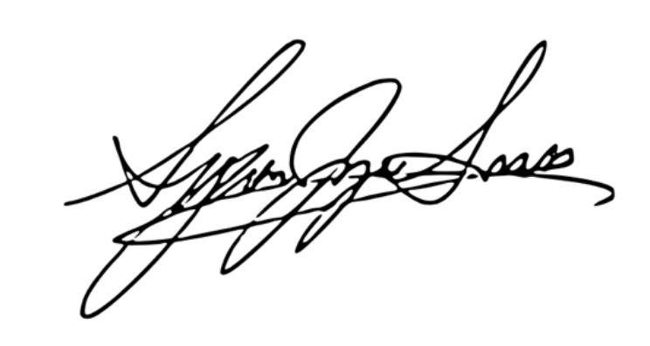

Syuan-Jyun Sun (corresponding author)

On behalf of Gen-Chang Hsu, Wei-Jiun Lin, Chi-Heng Hsieh, and Yue-Jia Lee